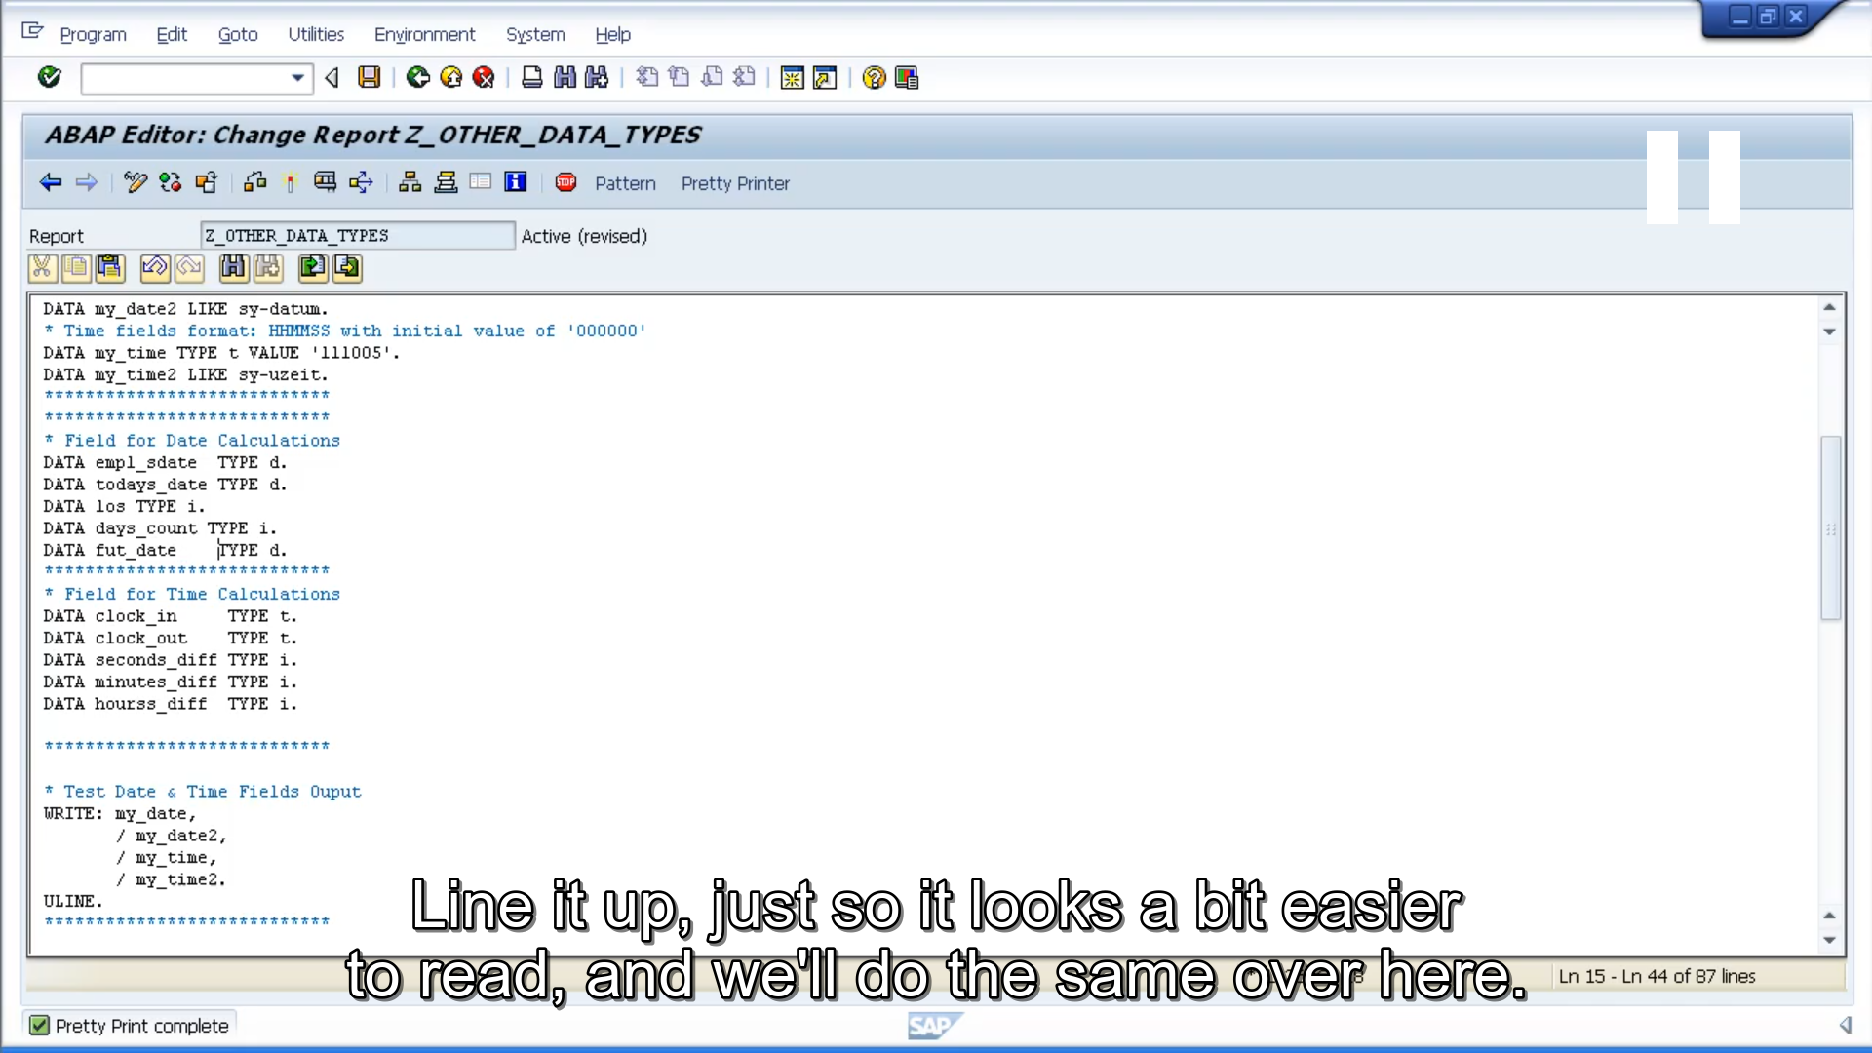

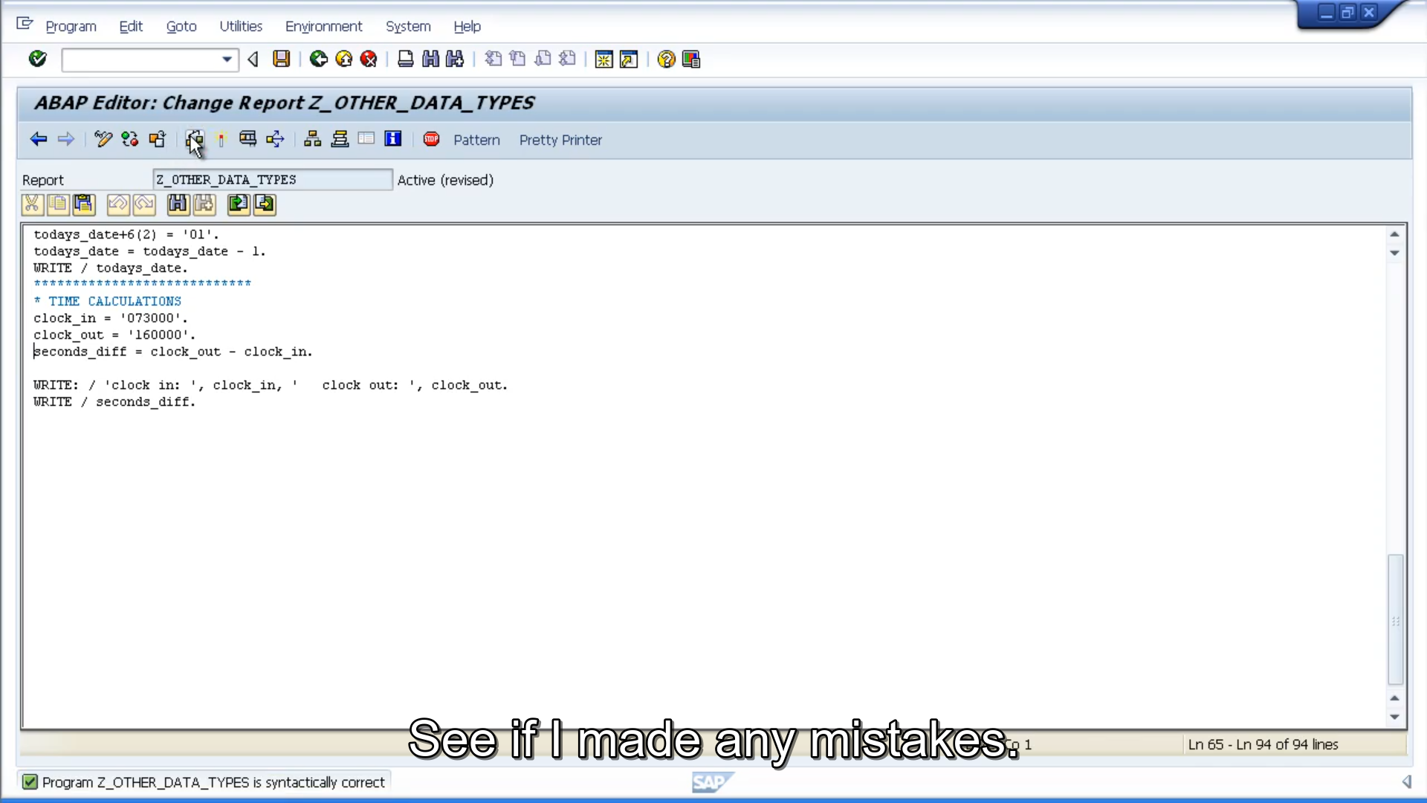

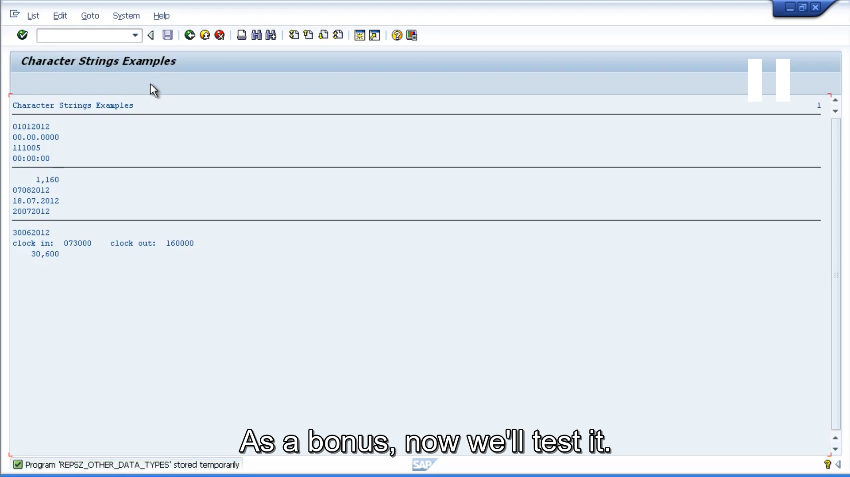

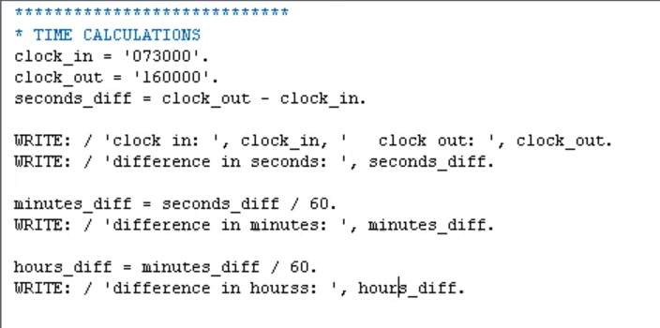

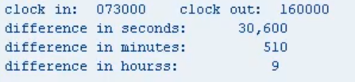

Hopefully, you recognize that the hours diff was an integer. If we'd made it a decimal, we would have got a decimal result. Giving us eight and a half hours difference. But because it was an integer it was rounded up to 9.

You want to check it out, let's change that integer to a decimal. So, what we need to do, is moved to the data declaration part, and where we have an integer, let's change it to a pack decimal. And remember, we need to specify how many decimal places we want. We'll put 2.

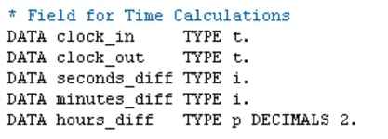

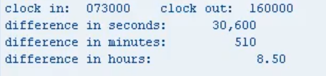

Everything looks good, we'll activate it and then test it out. And as you can see, the results now are 8.5 hours.